Question / Concern

1. How should we assign the ORIGIN for those --TESTCD = --ALL? The current process is in VARDEF assign the CRF to --ORRES and leaves the CRF page as missing. The reason is we don’t annotate the --ORRES in the aCRF. And in VALDEF, assign the ORIGIN as CRF and keep the CRF page as missing, since the ORIGIN in VALDEF should be consistent with ORIGIN in VARDEF (--ORRES). Please confirm if this is okay and can be applied to all studies.

Sponsor: Keep the ORIGIN as CRF in both VARDEF and VALDEF. And the CRF page should also be added (an empty --ORRES is also an information about the --ORRES).

1. DM CRO can only download the DCM from SP, but the latest DCM is on SDD and sometimes is not consistent with SP. Also, it will be better to have a version control for the DCM if only the latest DCM will be uploaded on SP, as sometimes DM CRO needs to update the annotation based on the latest DCM. But we will barely know what been changed.

Sponsor: Will discuss with their IT to see if SDD access can provide to DM CRO. DM CRO can request GDM to provide all the DCMs which were used in the study. In case DM CRO wants to refer the DCM on sharepoint, then please only check those Released and Finalized DCM, don’t use those Draft ones.

1. It said, for mCTMS, we can download final SDTM DV dataset directly from sFTP eventually. But currently we download the csv file from imedidata and doing the mapping in our end, not sure when can this new process been implemented.

Sponsor: Will check with standard team and keep us posted.

1. Is it possible to provide the Trial Design domains to DM CRO in the SDTM set-up package? I understand it may take time to complete the TS domain but we need at least TA / TE / TI / TV at least as it’s related to EPOCH / SE / DM (ARMCD / ARM / ACTARMCD / ACTARM) / IE / SV.

Sponsor: It’s difficult for GDM to provide the Trial Design domains in the EDC Set up package. However, it’s doable to provide the Trial Design domains in SDTM set-up package. To create the Trial Design domains in SDD takes a lot of manual work and the in-between process may be GDM provide the excel file first for DM CRO to proceed. Also, probably the TS domain will be provided in a later stage as it will not affect other domains.

1. Do you have any plan to change Define v1.0 to Define v2.0? As the structure between these two versions are very different. If you have the plan, do you know when the guidance will be released?

Sponsor: This upgrade is planned but not soon. We need to use Define v1.0 for now. Submission Team will inform all internal /external vendor colleagues as soon as the change to v2.0 is in the planning.

1. What kind of changes will impact the iDART? Because sometimes we want to change something but GDM will tell us on hold as it may impact the iDART.

Sponsor: Basically the iDART use TEST (--TEST) / LABEL (QLABEL) to link with SDTM datasets, so if such variables change then it will impact iDART. Except for this, GDM should know what kind of changes will impact iDART and what kind of changes will not. So, for now please discuss with your GDM for anything which is unsure and sponsor will check if there is any training can be provided to DM CRO.

1. It said GDM should review the DMCC report and provide comments before sending the report to DM CRO but sometimes GDM just send the whole DMCC report to DM CRO without any comments. The same issue happened in Pinnacle 21 report. Also few GDM request DM CRO to create the trail design domains. If in the future we encountered such case, can we push back to GDM?

Sponsor: DM CRO can push back to GDM if the report is sent without clarification. Sometimes reports are clear enough without clarification, so DM CRO should be able to update the database. But DMCC reports cover also checks at this moment that are not yet completely correct. It is up to the GDM to filter out these invalid checks from the DMCC report, or to clarify to the CRO.

Creation of Trial Design domains is in collaboration of the GDM & DM CRO. GDM can create the SDD domains in SDD platform. In case it is requested from the DM CRO to create, this should be discussed between DM CRO & GDM/DDL on trial-level. In this situation, a trial design spec sheet will be provided to the DM CRO.

You can refer to the Communication Plan, created on trial-level, to use the appropriate communication flows when needed (Line Manager -> Lily -> Gert -> GDM).

Metadata Issue (20151219)

1. Duplicate Issue (Records have the same CODEVAL but have different DECOD): Some issues were discussed in previous metadata package 20151110 (i.e. below highlighted LBUNIT) so we know which one should be selected. But I think the new metadata should fix all these issues so we will know which one should be used in our studies.

Sponsor: Code lists seem to be updated in 20160606 on Sharepoint, excluding the duplicate values.  
  
Please be informed that Sharepoint Metadata files should be in sync with Hermes SDD Library module. This was a discussion we had and it is confirmed that Sharepoint is kept in sync with the SDD platform. Hence, Sharepoint is a trustworthy source for SDTM programming.

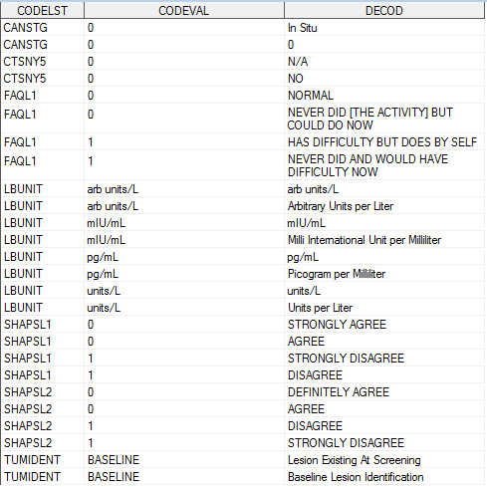

1. Duplicate Issue (Records have the same DECOD but have different CODEVAL): Some issues were discussed in previous metadata package 20151110 (i.e. below highlighted FREQ) so we know which one should be selected. But I think the new metadata should fix all these issues so we will know which one should be used in our studies.

Sponsor: FRQ Resolved.  
ADJ and LBUNIT is passed to Standards Team to look into.

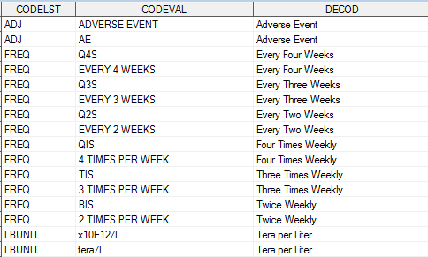

1. Ludwig unit (LBORRESU) is not consistent with unit in CD metadata (CODELST=LBUNIT). I supposed the meaning of below units are the same, but the term are not 100% the same. Study team is confused and not sure which one should we follow.

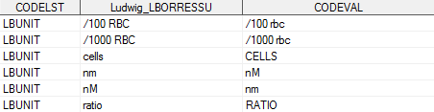

1. Ludwig unit (LBSTRESU) is not consistent with unit in CD metadata (CODELST= LBSTDUNIT). I supposed the meaning of below units are the same, but the term are not 100% the same. Not sure which one should we follow.



1. Not sure how to assign the RNK in CD metadata. I asked the question in new submission requirement training, and the trainer said RNK should only be populated when there is a meaningful ordering to the values within each codeList. However, I saw in the latest metadata, RNK is provided for all codelist. Please provide the rule when assign the RNK.

Sponsor: Submission Team will follow up with Standards Team to clarify (if current CD is present as expected or not)

1. Follow Janssen standard, in VARDEF, the VALUELST should not be missing for those Findings and SUPP domains. However, below domains the VALUELST are missing.

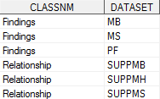

1. Follow Janssen standard, for those Derived variables, either COMMENTS or COMPMETH should be provided. Please see below table, in current VARDEF, there are some Derived variables don’t have COMMENTS or COMPMETH. I understand for some variables the deviation rule will be different in different studies, but some variables the derivation rule are pretty standard which I think should be added. Or, probably the ORIGIN should be revised.

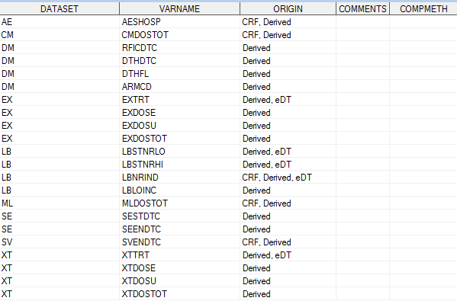

1. According to Define.xml Appendix I, we have some conditional variables which should be included in the dataset at the same time and also I think the CORE should consider each other. I list below some issues for your reference.
   1. AE: We have AEPRESP but we don’t have AEOCCUR
   2. CO: We have CODTC but we don’t have CODY
   3. EX: CORE of EXENDTC is “Exp” but CORE of EXENDY is “Perm”
   4. PE: We have PEORRESU but we don’t have PESTRESU and PESTRESN
   5. PP: We have PPDTC but we don’t have PPDY
   6. PP: We have PPTPTREF but we don’t have PPTPT / PPTPTNUM
   7. PR: CORE of PRSTDTC is “Exp” but CORE of PRSTDY is “Perm”
   8. QS: CORE of QSDTC is “Exp” but CORE of QSDY is “Perm”
   9. SU: CORE of SUENDY is “Exp” but CORE of SUENDTC is “Perm”
   10. ZP: We have ZPDTC but we don’t have ZPDY
   11. ZP: We have ZPTPTREF but we don’t have ZPTPT / ZPTPTNUM
   12. ZR: CORE of Z ZRSTRESN is “Exp” but CORE of ZRORRESU / ZRSTRESU is “Perm”